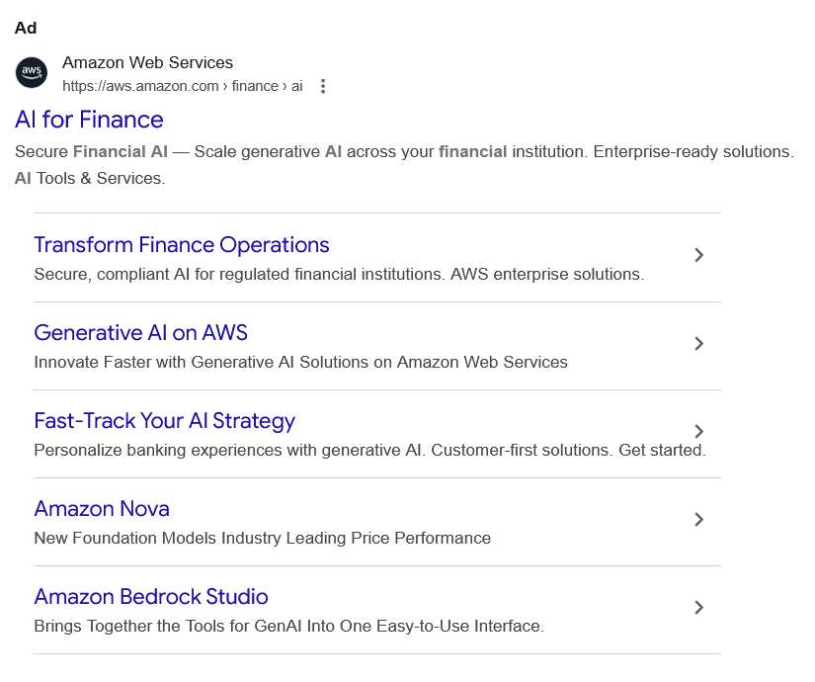
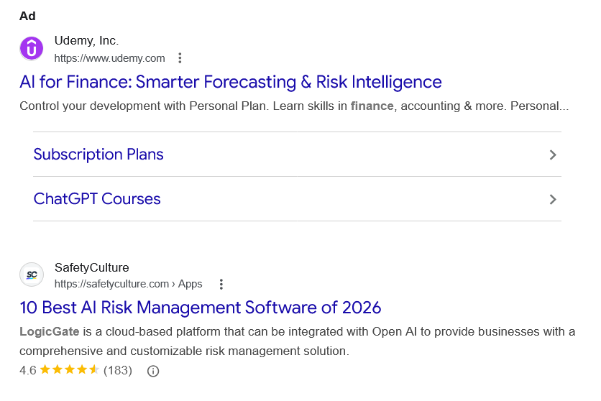
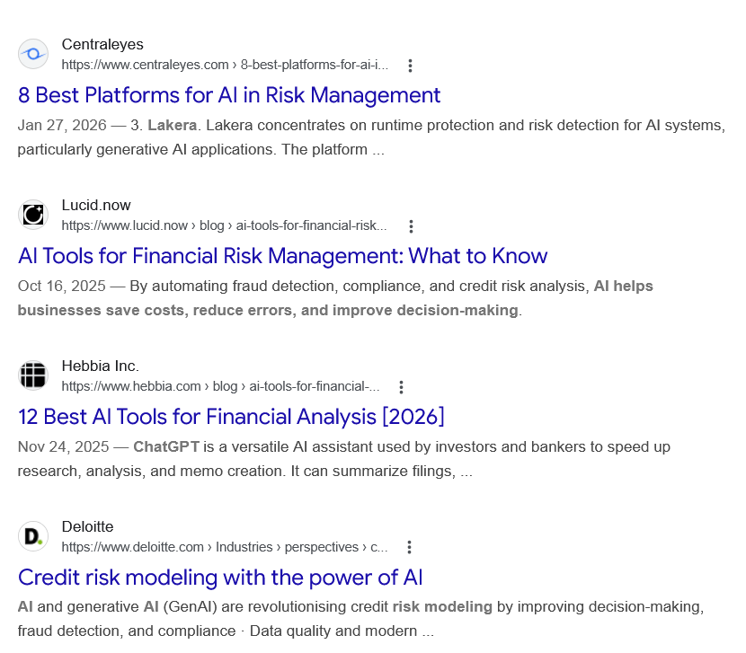
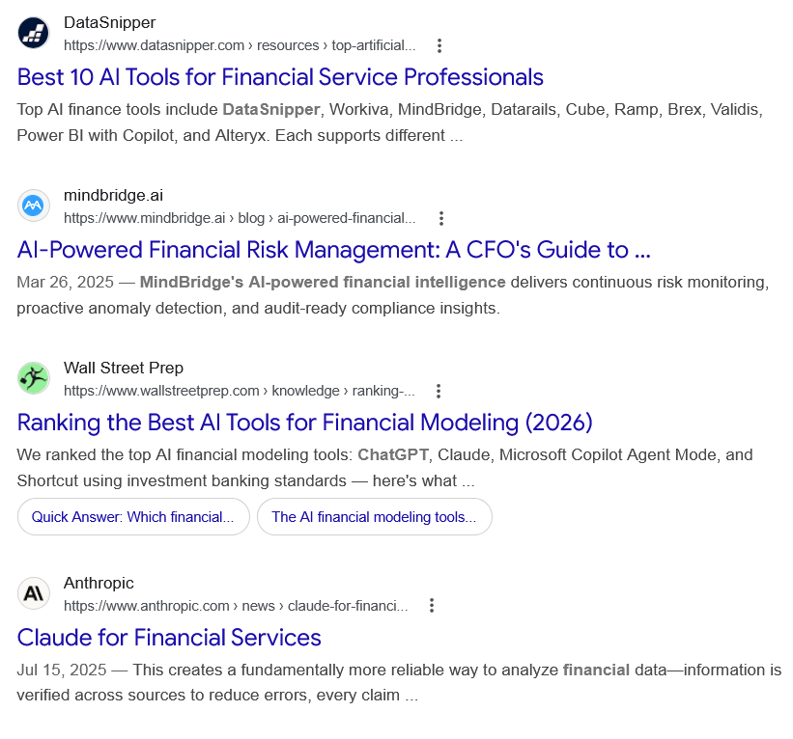
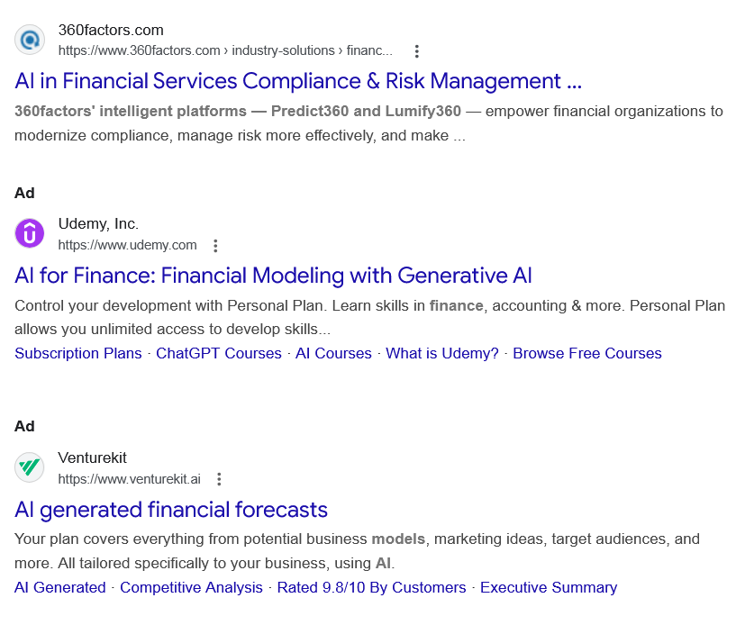
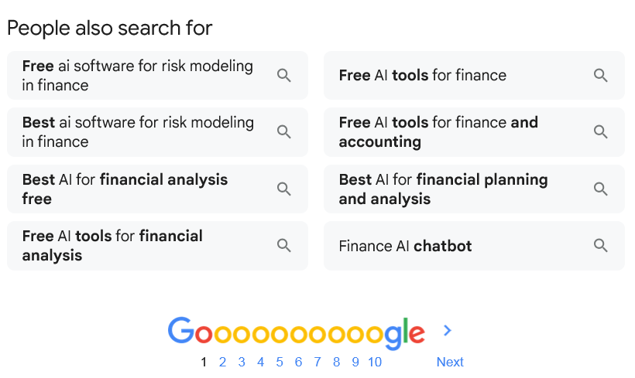
Ad

AI for Finance
Amazon Web Services
https://aws.amazon.com › finance › ai

Amazon Web Services
https://aws.amazon.com › finance › ai

My Ad Centre
Secure Financial AI — Scale generative AI across your financial institution. Enterprise-ready solutions. AI Tools & Services.

Transform Finance Operations
Secure, compliant AI for regulated financial institutions. AWS enterprise solutions.

Generative AI on AWS
Innovate Faster with Generative AI Solutions on Amazon Web Services

Fast-Track Your AI Strategy
Personalize banking experiences with generative AI. Customer-first solutions. Get started.

Amazon Nova
New Foundation Models Industry Leading Price Performance

Amazon Bedrock Studio
Brings Together the Tools for GenAI Into One Easy-to-Use Interface.

People also search for
Ad

AI for Finance: Smarter Forecasting & Risk Intelligence
Udemy, Inc.
https://www.udemy.com

Udemy, Inc.
https://www.udemy.com

My Ad Centre
Control your development with Personal Plan. Learn skills in finance, accounting & more. Personal...

Subscription Plans

ChatGPT Courses

People also search for

Web results

10 Best AI Risk Management Software of 2026

SafetyCulture
https://safetyculture.com › Apps

SafetyCulture
https://safetyculture.com › Apps
LogicGate is a cloud-based platform that can be integrated with Open AI to provide businesses with a comprehensive and customizable risk management solution.
4.6(183)

Web results

8 Best Platforms for AI in Risk Management

Centraleyes
https://www.centraleyes.com › 8-best-platforms-for-ai-i...

Centraleyes
https://www.centraleyes.com › 8-best-platforms-for-ai-i...
Jan 27, 2026 — 3. Lakera. Lakera concentrates on runtime protection and risk detection for AI systems, particularly generative AI applications. The platform ...

AI Tools for Financial Risk Management: What to Know

Lucid.now
https://www.lucid.now › blog › ai-tools-for-financial-risk...

Lucid.now
https://www.lucid.now › blog › ai-tools-for-financial-risk...
Oct 16, 2025 — By automating fraud detection, compliance, and credit risk analysis, AI helps businesses save costs, reduce errors, and improve decision-making.

12 Best AI Tools for Financial Analysis [2026]

Hebbia Inc.
https://www.hebbia.com › blog › ai-tools-for-financial-...

Hebbia Inc.
https://www.hebbia.com › blog › ai-tools-for-financial-...
Nov 24, 2025 — ChatGPT is a versatile AI assistant used by investors and bankers to speed up research, analysis, and memo creation. It can summarize filings, ...

Credit risk modeling with the power of AI

Deloitte
https://www.deloitte.com › Industries › perspectives › c...

Deloitte
https://www.deloitte.com › Industries › perspectives › c...
AI and generative AI (GenAI) are revolutionising credit risk modeling by improving decision-making, fraud detection, and compliance · Data quality and modern ...

Best 10 AI Tools for Financial Service Professionals

DataSnipper
https://www.datasnipper.com › resources › top-artificial...

DataSnipper
https://www.datasnipper.com › resources › top-artificial...
Top AI finance tools include DataSnipper, Workiva, MindBridge, Datarails, Cube, Ramp, Brex, Validis, Power BI with Copilot, and Alteryx. Each supports different ...

AI-Powered Financial Risk Management: A CFO's Guide to ...

mindbridge.ai
https://www.mindbridge.ai › blog › ai-powered-financial...

mindbridge.ai
https://www.mindbridge.ai › blog › ai-powered-financial...
Mar 26, 2025 — MindBridge's AI-powered financial intelligence delivers continuous risk monitoring, proactive anomaly detection, and audit-ready compliance insights.

Ranking the Best AI Tools for Financial Modeling (2026)

Wall Street Prep
https://www.wallstreetprep.com › knowledge › ranking-...

Wall Street Prep
https://www.wallstreetprep.com › knowledge › ranking-...
We ranked the top AI financial modeling tools: ChatGPT, Claude, Microsoft Copilot Agent Mode, and Shortcut using investment banking standards — here's what ...
•
Quick Answer: Which financial...

•
The AI financial modeling tools...

Claude for Financial Services

Anthropic
https://www.anthropic.com › news › claude-for-financi...

Anthropic
https://www.anthropic.com › news › claude-for-financi...
Jul 15, 2025 — This creates a fundamentally more reliable way to analyze financial data—information is verified across sources to reduce errors, every claim ...

AI in Financial Services Compliance & Risk Management ...

360factors.com
https://www.360factors.com › industry-solutions › financ...

360factors.com
https://www.360factors.com › industry-solutions › financ...
360factors' intelligent platforms — Predict360 and Lumify360 — empower financial organizations to modernize compliance, manage risk more effectively, and make ...
Ad

AI for Finance: Financial Modeling with Generative AI
Udemy, Inc.
https://www.udemy.com

Udemy, Inc.
https://www.udemy.com

My Ad Centre
Control your development with Personal Plan. Learn skills in finance, accounting & more. Personal Plan allows you unlimited access to develop skills...
‎Subscription Plans · ‎ChatGPT Courses · ‎AI Courses · ‎What is Udemy? · ‎Browse Free Courses
Ad

AI generated financial forecasts

Venturekit
https://www.venturekit.ai

Venturekit
https://www.venturekit.ai

My Ad Centre
Your plan covers everything from potential business models, marketing ideas, target audiences, and more. All tailored specifically to your business, using AI.
‎AI Generated · ‎Competitive Analysis · ‎Rated 9.8/10 By Customers · ‎Executive Summary
People also search for

Free ai software for risk modeling in finance

Best ai software for risk modeling in finance

Best AI for financial analysis free

Free AI tools for financial analysis

Free AI tools for finance

Free AI tools for finance and accounting

Best AI for financial planning and analysis

Finance AI chatbot

Page navigation
 | 1 | 2 | 3 | 4 | 5 | 6 | 7 | 8 | 9 | 10 | Next

